**9**

**8**

**7**

**6**

**5**

**4**

**1**

**3**

**2**

**10**

**

**3**

**2**

**1**

**1**

**

**2**

**2**

**1**

**3**

**1**

**9**

**8**

**7**

**6**

**5**

**4**

**1**

**3**

**2**

**10**

**

**6**

**7**

**5**

**4**

**3**

**2**

**1**

**1**

**2**

**3**

**9**

**8**

**7**

**6**

**5**

**4**

**3**

**2**

**10**

**

**1**

**9**

**8**

**7**

**10**

**

**6**

**5**

**4**

**3**

**2**

**1**

**9**

**8**

**7**

**6**

**5**

**4**

**1**

**3**

**2**

**10**

**

**6**

**9**

**8**

**7**

**10**

**

**5**

**4**

**3**

**2**

**1**

**9**

**8**

**7**

**6**

**10**

**

**5**

**4**

**3**

**2**

**1**

**9**

**8**

**7**

**6**

**5**

**4**

**3**

**2**

**10**

**1**

**9**

**8**

**7**

**6**

**5**

**4**

**10**

**

**1**

**2**

**3**

**9**

**8**

**7**

**6**

**5**

**4**

**3**

**10**

**

**2**

**3**

**1**

**9**

**8**

**7**

**6**

**5**

**10**

**

**3**

**2**

**1**

**4**

**9**

**8**

**7**

**6**

**5**

**4**

**1**

**3**

**2**

**10**

**1**

**1**

**1**

**1**

**1**

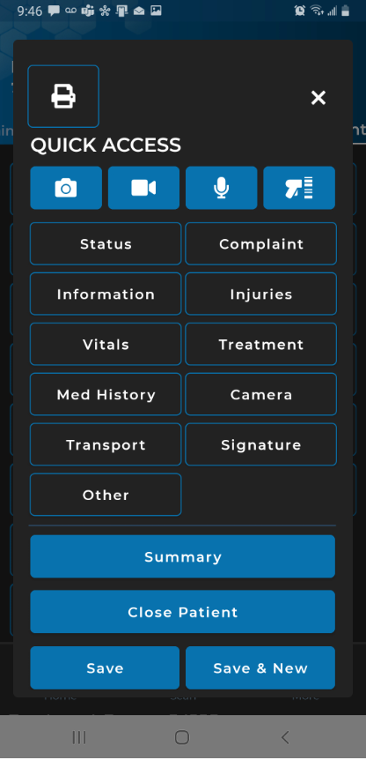

**4/**

**3**

**2**

**1**

**1**

**1**

**

**2**

**3**

**4**

**1**

**

**1**

**1**

**3**

**2**

**2**

**1**

